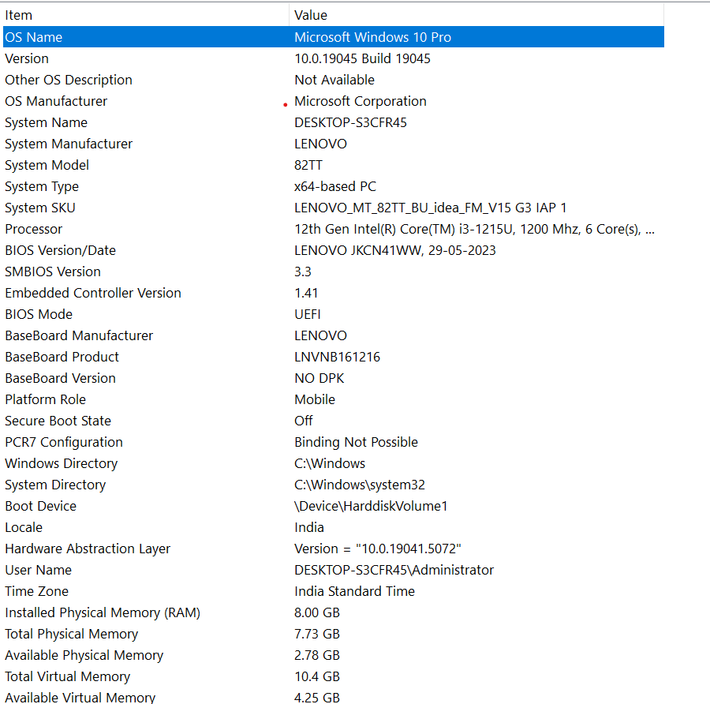
- On your Windows laptop or PC, open 'System Information' and take a screenshot showing your OS version, processor, and RAM details.

- Download any official Linux distribution ISO (like Ubuntu or Fedora), and use Rufus or BalenaEtcher to create a bootable USB drive for installation. Hint: If you don't have a spare USB, use a virtual machine tool like Virtual Box to mount the ISO and start the installation process virtually.

Step 1: Download the Linux ISO
- Ubuntu Linux
- A beginner-friendly Linux distribution.
- Download from the official website: ubuntu.com/download/desktop
- Download the ISO file and save it somewhere easy to find, such as your Downloads folder.

Step 2: Download Rufus
- Rufus
- A free tool for creating bootable USB drives.
- Download from the official website: rufus.ie

Step 3: Create the bootable USB drive
- You need a USB flash drive with at least 8 GB of storage. Back up any files on it first, because Rufus will erase the USB drive.
1. Insert the USB drive
- Open Rufus and select your USB drive under Device.
2. Select the ISO file
- Click SELECT, find the downloaded Ubuntu .iso file, and open it.
3. Check the settings
- Keep the recommended default settings unless you know your computer requires different ones.
4. Start writing
- Click START, confirm the data-erasure warning, and wait until Rufus displays READY.
- These steps follow Ubuntu's official Rufus guide

Step 4: Start Linux from the USB
- Restart your computer with the USB drive inserted.
- Open the boot menu by pressing the appropriate key for your computer, often F12, F9, Esc, or F11.
- Select the USB drive.
- When Ubuntu starts, choose Try Ubuntu to test it without installing, or start the installer if you want to install Linux.

- On a macOS device (or using a macOS virtual machine), open 'System Preferences' and change the desktop wallpaper, then adjust the system language to Hindi or Gujarati. Hint: Find 'Language & Region' in System Preferences to add or change languages.

Part 1: Change the desktop wallpaper
- Step 1: Open the Apple menu () in the top-left corner and select System Preferences.
- Step 2: Click Desktop & Screen Saver (older macOS versions) or Desktop & Wallpaper.
- Step 3: Select a new wallpaper from the available pictures or choose an image from your files.
- The desktop background changes to your selected image.

Part 2: Change the system language to Hindi or Gujarati
- Step 1: Return to System Preferences and open Language & Region.
- Step 2: Click the + (plus) button under Preferred Languages.
- Step 3: Search for Hindi or Gujarati, select your preferred language, and click Add.
- Step 4: If prompted, choose to use the newly added language as the primary language. If needed, drag it to the top of the preferred languages list.
- macOS will use Hindi or Gujarati for supported menus and applications. You may need to log out and log back in, or restart, for the changes to take effect.

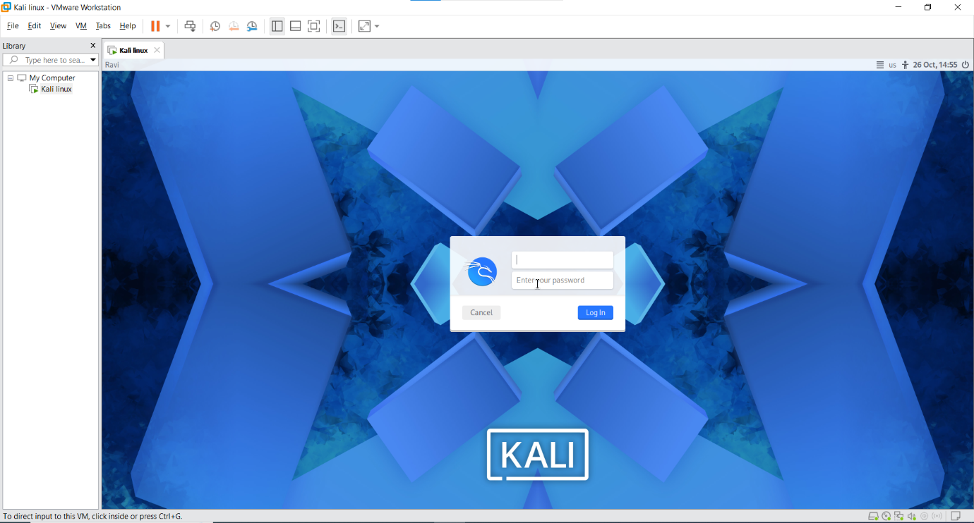
- Install a fresh copy of Ubuntu Linux (real or virtual machine) and create a new user account named 'gamer'. After installation, enable automatic login for this user and take a screenshot of the login screen showing the username.

